

Course Title: | Digital Systems Engineering
Course Number: | COE 758
Semester/Year (e.g.F2016) | F2021

Instructor: | Lev Kirischian

Assignment/Lab Number: | 2
Assignment/Lab Title: | Simple Video Game Processor for VGA

Submission Date : | 2021-12-03
Due Date: | 2021-12-06

Student  LAST Name | Student  FIRST Name | Student Number | Section | Signature*
Chen | Rick | 500909131 | 02 | 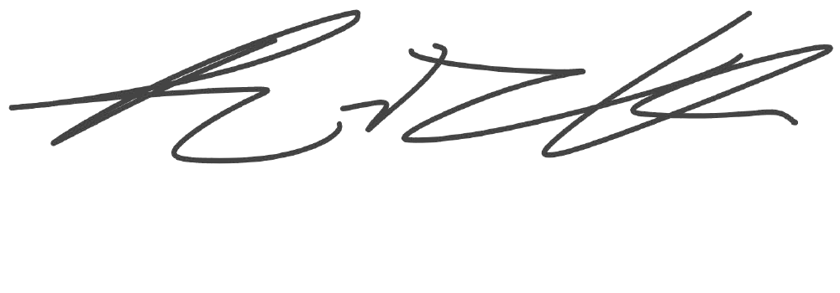
Tilayof | David | 500679922 | 02 | David Tilayof
*By signing above you attest that you have contributed to this written lab report and confirm that all work you have contributed to this lab report is your own work. Any suspicion of copying or plagiarism in this work will result in an investigation of Academic Misconduct and may result in a “0” on the work, an “F” in the course, or possibly more severe penalties, as well as a Disciplinary Notice on your academic record under the Student Code of Academic Conduct, which can be found online at: http://www.ryerson.ca/senate/current/pol60.pdf

Abstract
The objective of this project is to learn about on-chip (FPGA) to I/O interfacing, the Video Graphic Adapter (VGA) standard, as well as how a video-output subsystem functions. To achieve this we will be creating a simple pong video game in VHDL. Video games such as pong make use of all the components we are trying to learn about in this project. The controls and monitor that will be connected can give us the opportunity to explore the I/O interface of the FPGA. While the display output gives us a chance to learn about the video-output subsystem as well as the VGA standard as a whole. In Addition to the previous goals we also hope to gain experience in designing and implementing real-time high-performance signal generators and custom logic circuits. Finally, we are also aiming to learn what we can about VHDL coding for real-time applications within the Xilinx ISE CAD environment.

Introduction
In this project our aim is to design and implement a simple video game processor (SVGP). The SVGP receives user inputs and uses them to determine how dynamic elements of the game behave. In addition to this the SVGP also handles the behavior of dynamic elements when they interact with one another. Finally the SVGP outputs the static and dynamic elements of the video game to the monitor using the VGA standard. The video game that we will be creating using the SVGP is pong. In pong a ball moves around the screen until it hits either the border, a player's paddle, or the goal. If the ball hits either the border or the paddle the ball will bounce off and travel at ±90° from its initial direction. If, on the other hand, the ball reaches the goal the ball will turn red, disappear, and a new ball will appear in the center of the screen. The static elements of the game include the green field and the white border. The dynamic elements of the game are the yellow ball and the blue and pink paddles. The VGA standard uses red, green, and blue signals to display color. The colour of each pixel on the screen is represented by some mix of red, green and blue. Hsync and Vsync signals are pulses that signify the start and end of each line and frame respectively. The active image area of the simulated VGA display is set to be 640✕480 pixels. The simulated VGA display we are using for this project requires the current simulated time in ns, the Hsync signal, the Vsync signal, a 3-bit red signal, a 3-bit green signal, and a 2-bit blue signal.

System Specifications

Simple Video Game Processor:
Functional Specifications:
- Monitor clock signal.
- Integers that keep track of the horizontal and vertical position are updated every clock cycle.
- The Hsync/Vsync signals are asserted while the horizontal/vertical position is less than the front porch + active image area or when the horizontal/vertical position is greater than the front porch + active image area + sync pulse.
- Displays the static and dynamic elements on the monitor.
- Keeps track of internal signals for position and velocity of dynamic elements.
- The velocity of paddles is set depending on SW signals.
- Sets new velocity for the ball when it comes in contact with paddles or borders.
- Calculates the next position of the dynamic elements using position and velocity values of elements.

Technical Specifications:
- The clk signal is used to generate the clk_DAC signal that has a frequency of 25 MHz.
- On the rising edge of every clock cycle the integer representing the horizontal position is incremented.
- After every 800 clock cycles the integer for the horizontal position is reset and the integer for the vertical position is incremented.
- Once the integer for the vertical position reaches 525 the vertical position integer is reset.
- The Hsync signal is set high for 656 clock cycles, set low for 96 clock cycles and then set high for 48 clock cycles. After which the process repeats.
- The Vsync signal is set high for 490 Hsync cycles, set low for 2 Hsync cycles and then set high for 33 Hsync cycles. After which the process repeats.
- While the horizontal position is less than 640 and the vertical position is less than 480 then RGB data is sent to Red_Out, Green_Out, and Blue_Out ports.
- If SW0/SW2 signal is asserted then the vertical velocity of Player1/Player2’s paddle is set to a positive value.
- If SW1/SW3 signal is asserted then the vertical velocity of Player1/Player2’s paddle is set to a negative value.
- If the ball makes contact with the top or bottom borders the ball's vertical velocity is multiplied by -1.
- If the ball makes contact with the paddles or side borders the ball's horizontal velocity is multiplied by -1.
- The next position of the dynamic elements is calculated by adding the horizontal velocity or vertical velocity values to the current horizontal and vertical positions.

Device Design

- Symbols

The video game processor has 5 input signals and 6 output signals. The input signals consist of the clock, P1_up, P1_down, P2_up, and P2_down signals. The function of all the input signals with the exception of the clock signal is to act as controller inputs for the paddles. The output signals for the game are the clk_DAC, H_sync_VGA, V_sync_VGA signals as well as the 8-bit Red_Out, Green_Out, and Blue_Out signals.

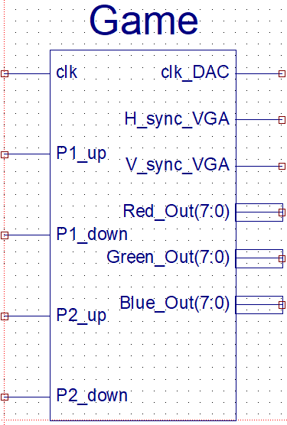
Figure1. Game

- VGA Specifications

Parameter | Clock Cycles
Complete line | 800
Front Porch | 16
Sync Pulse | 96
Back Porch | 48
Active Image Area | 640
Table 1. VGA Horizontal Parameters

Parameter | Lines
Complete line | 525
Front Porch | 10
Sync Pulse | 2
Back Porch | 33
Active Image Area | 480
Table 2. VGA Vertical Parameters

- Block diagram

The block diagram below shows the structure of the simple video game processor created in this project. The game block receives inputs from the clock and the users and processes the information and outputs clock, Hsync, Vsync and RGB signals that get sent to a text file. We are able to later upload the text file to a VGA simulator to get a display from the game.
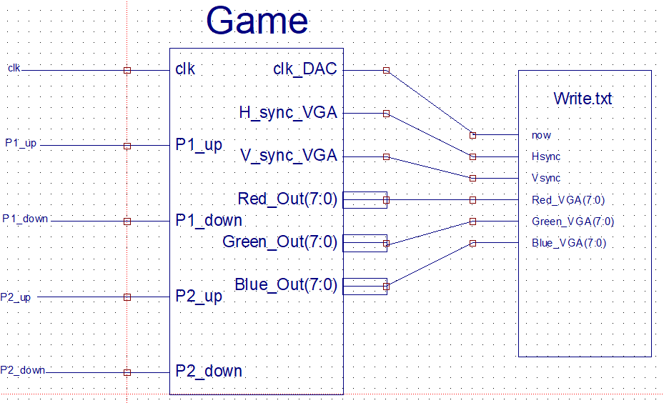
Figure3. Block Diagram

- Process diagram

The figure below shows the behaviour of the system. After the program starts the rising edge of the clock signal prompts the game processor to check if a new frame is being generated. As the program has just started the initial state is yes so the program moves on to check the player inputs and moves the paddles appropriately. The next step is to check the state of the ball. If the ball has collided with the paddles or the border the velocity of the ball will be updated before the ball continues traveling. If the ball has collided with the goal the ball is turned red before it is reset back to its original position and colour. However, at the start of the program the ball has not yet collided with any obstacles so it simply continues to its next position. The program waits for the next rising edge of the clock signal and once again checks if the frame has finished being displayed. As it has not the processor outputs the RGB values corresponding to the current horizontal and vertical position. The program then keeps repeating these steps ad infinitum until the program is terminated.

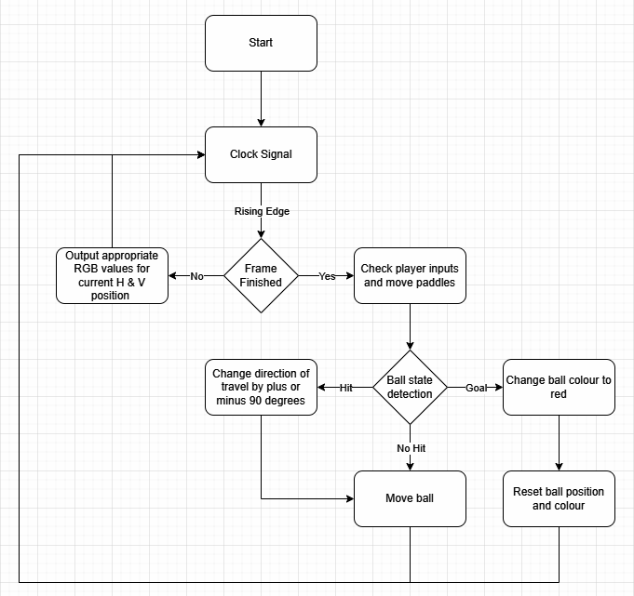
Figure4. Process Diagram

Results

- Timing diagram

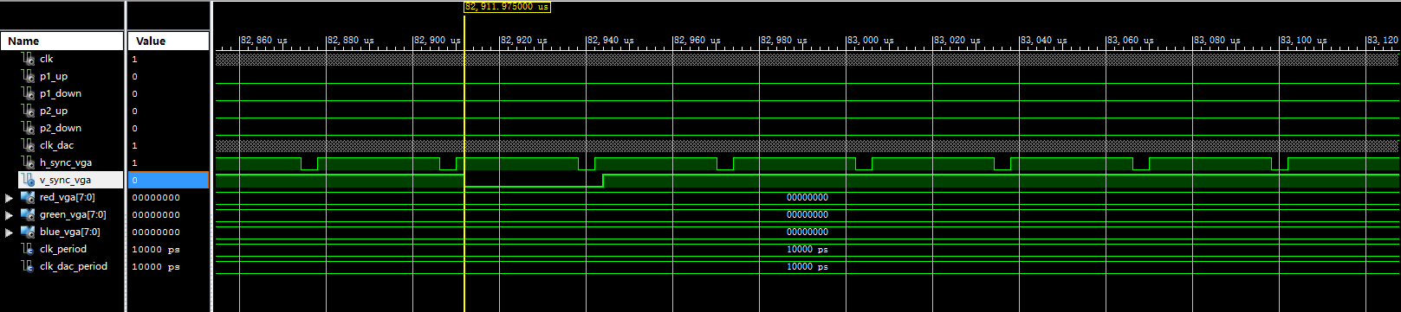
Figure5. Timing Diagram
- Screen Captures

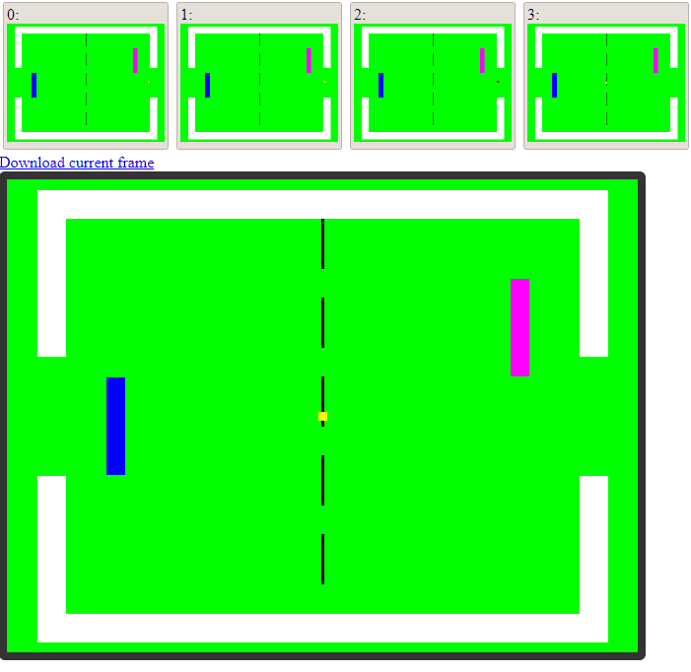
Figure6. Goal Behaviour

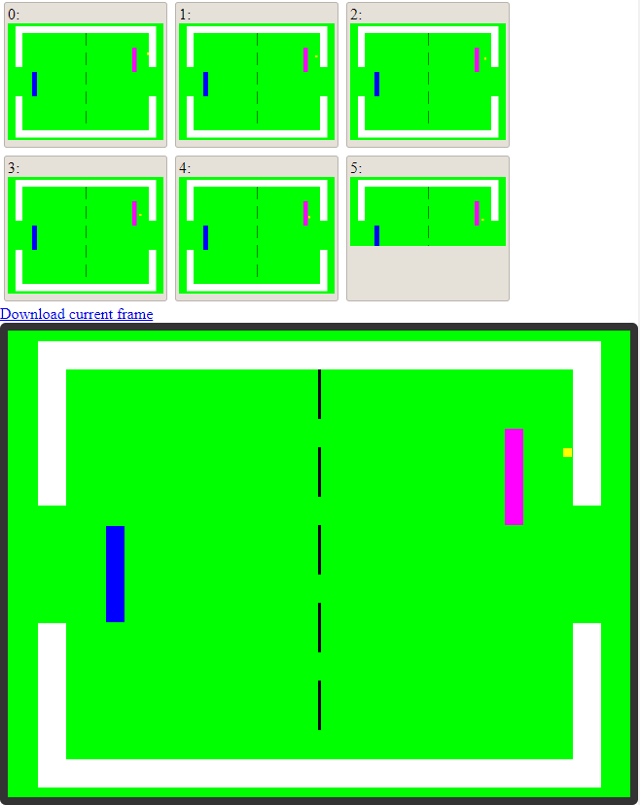
Figure7: Ball bounce horizontally

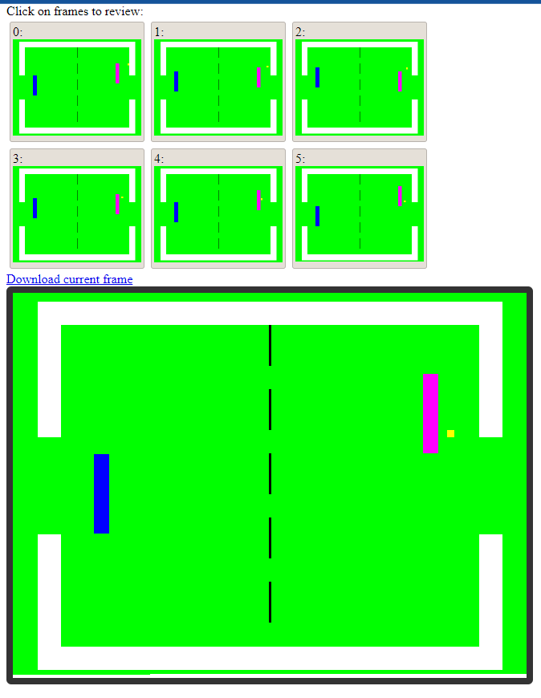
Figure8: Players control the paddle to move up and down
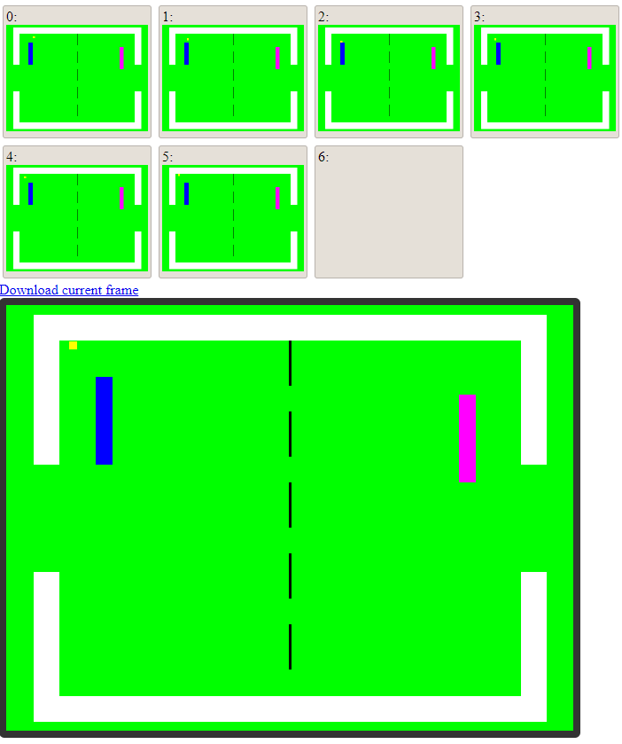
Figure9. Ball bounce vertically

- Explanation

For the waveform, the Figure5 shows when the vertical sync pulse is activated. For the simulation, the Figure6 Shows how the ball becomes red and then initializes the game after the goal. The Figure7 Shows how the ball bounces horizontally between the paddle and wall. How player 2 and player 1 are able to control the paddle is shown in Figure8. Last, the Figure9 shows how the ball bounces vertically between the paddle and wall.

Conclusion

In this project, we learned the functionality of the video-output subsystem and Video Graphic Adaptor standard and also on-chip to I/O device interfacing. To achieve that, we designed and implemented a simple video game processor (SVGP) in VHDL. Our design met all the specifications such as changing the ball’s trajectory when it hits the wall or paddle. Above that, we also added some other small details such as the paddle is unable to keep moving in the direction where it hits the wall to make the game better.

References
- Ryerson University - Lev Kirischian - COE758. (n.d.). Retrieved December 4, 2021, from https://www.ee.ryerson.ca/~lkirisch/coe758/coe758.htm.

Appendix
